Chapter 3, Solution 53

Applying mesh analysis leads to;
–12 + 4kI₁ – 3kI₂ – 1kI₃ = 0 (1)
–3kI₁ + 7kI₂ – 4kI₄ = 0
–3kI₁ + 7kI₂ = –12 (2)
–1kI₁ + 15kI₃ – 8kI₄ – 6kI₅ = 0
–1kI₁ + 15kI₃ – 6k = –24 (3)
I₄ = –3mA (4)
–6kI₃ – 8kI₄ + 16kI₅ = 0
–6kI₃ + 16kI₅ = –24 (5)
Putting these in matrix form (having substituted I₄ = 3mA in the above),

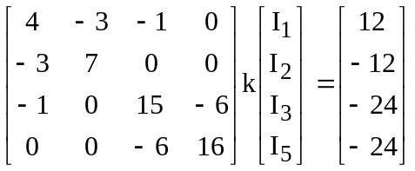

ZI = V

Using MATLAB,

>> Z = [4,-3,-1,0;-3,7,0,0;-1,0,15,-6;0,0,-6,16]

Z =

4 -3 -1 0
-3 7 0 0
-1 0 15 -6
0 0 -6 16

>> V = [12,-12,-24,-24]'

V =

12
-12
-24
-24

We obtain,

>> I = inv(Z)*V

I =
1.6196 mA
–1.0202 mA
–2.461 mA
3 mA
–2.423 mA

